Chapter 5

Rational Expressions, Equations, and Functions

Section 5.1: Simplifying Rational Expressions

- Rational Expressions

Rational Expressions

Definition:
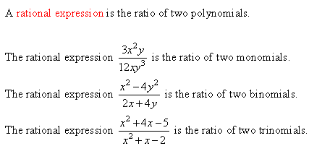

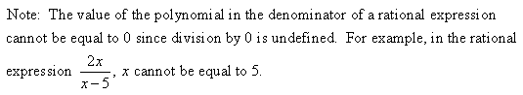

Simplifying:
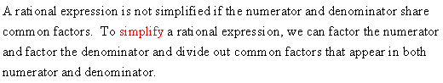

Example:
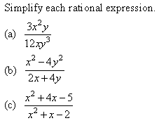

Solution:
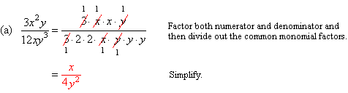

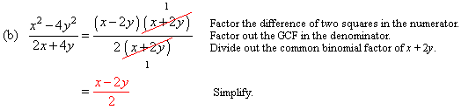

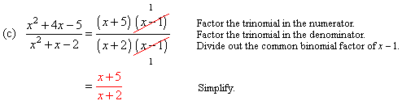

Additional Example 1:
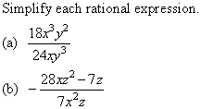

Solution:
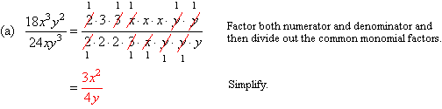

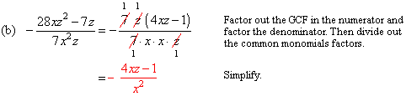

Additional Example 2:
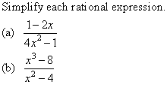

Solution:
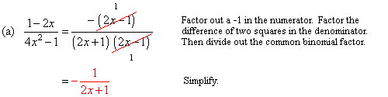
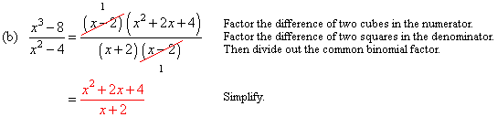

Additional Example 3:
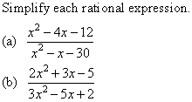

Solution:
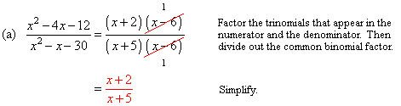

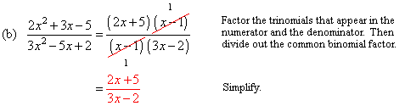

Additional Example 4:
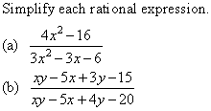
Solution:
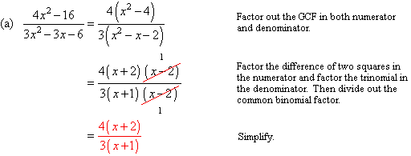

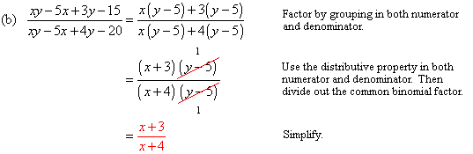

Simplify the following rational expressions. If the expression cannot be simplified any further, then simply rewrite the original expression.

Section 5.2: Multiplying and Dividing Rational Expressions

- Multiplication and Division

Multiplication and Division

Multiplication of Rational Expressions:
To multiply two fractions, place the product of the numerators over the product
of the denominators.

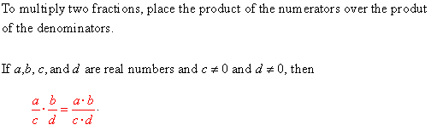

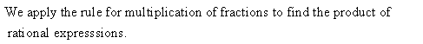

Example:
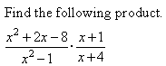

Solution:
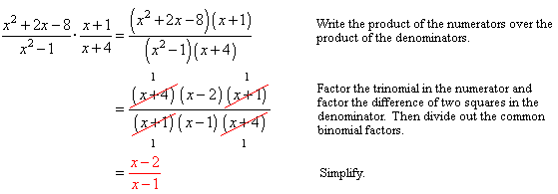
Division of Rational Expressions:
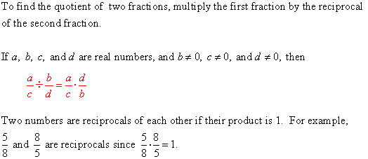

Example:
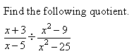

Solution:
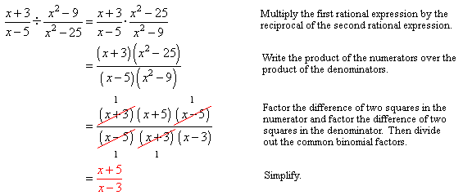

Additional Example 1:
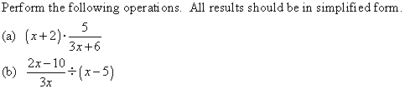

Solution:
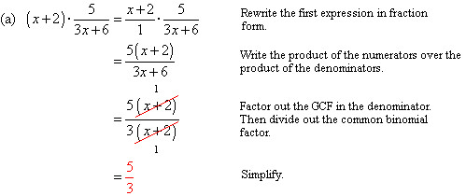

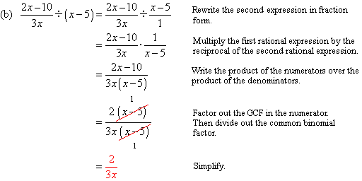

Additional Example 2:
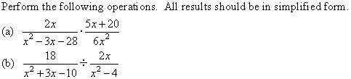
Solution:
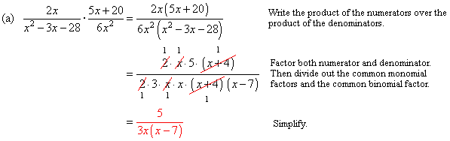

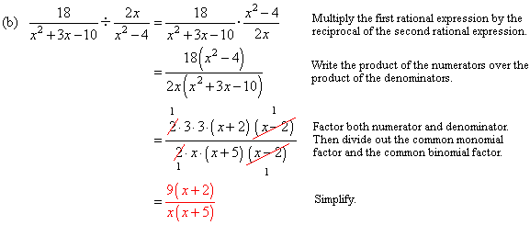

Additional Example 3:
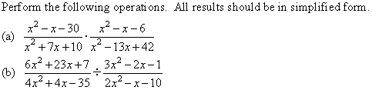

Solution:
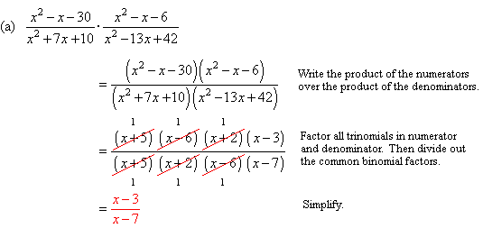

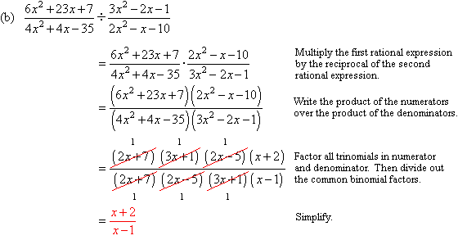

Multiply the following rational expressions and simplify. No answers should contain negative exponents.

Divide the following rational expressions and simplify. No answers should contain negative exponents.

Section 5.3: Adding and Subtracting Rational Expressions

- Addition and Subtraction

Addition and Subtraction

Addition and Subtraction of Rational Expressions with Like Denominators:
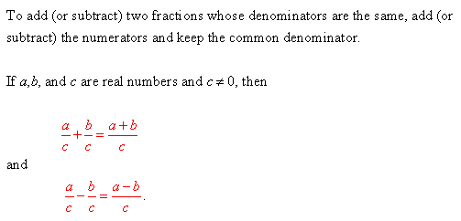

Example:
Perform the following operations. All results should be in simplified form.
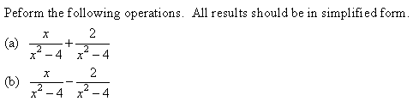
Solution:
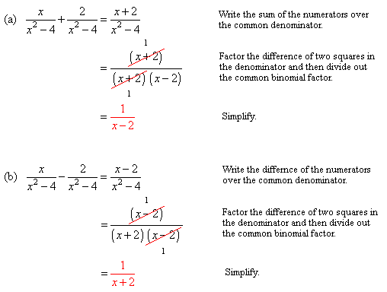

Addition and Subtraction of Rational Expressions with Unlike Denominators:
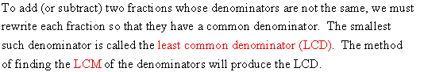

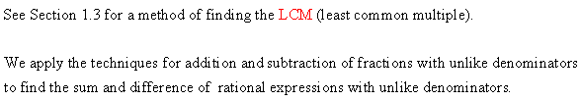

Example:
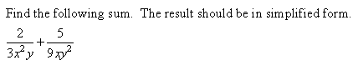
Solution:
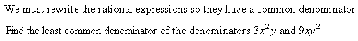

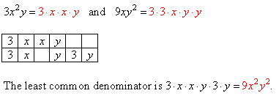

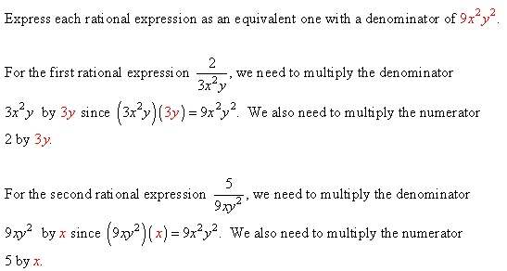

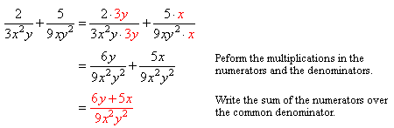

Additional Example 1:
Perform the following operations. All results should be in simplified form.
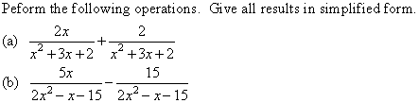
Solution:
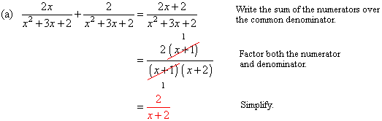

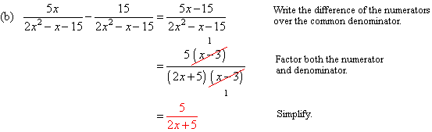

Additional Example 2:
Perform the addition. Give the result in simplified form.
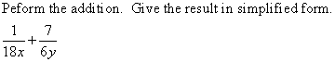

Solution:

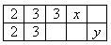

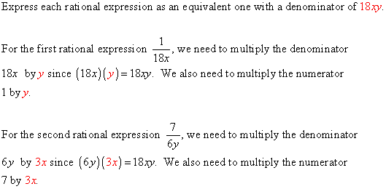

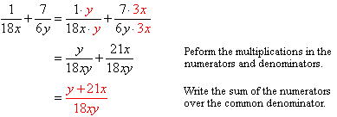

Additional Example 3:
Perform the subtraction. Give the result in simplified form.
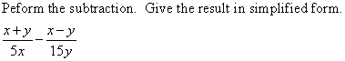

Solution:

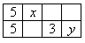

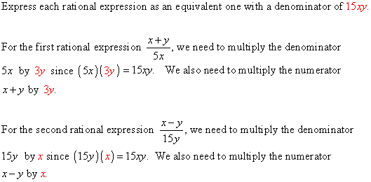

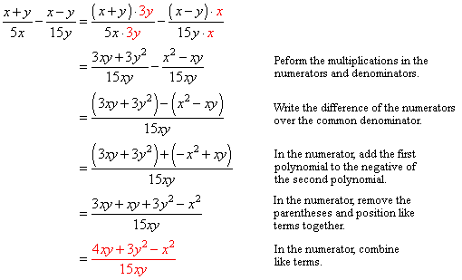

Additional Example 4:
Perform the subtraction. Give the result in simplified form.
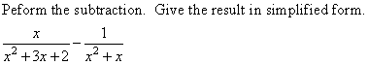

Solution:

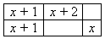

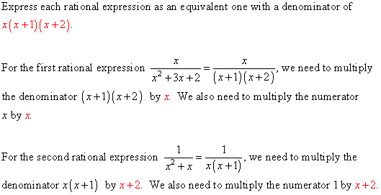

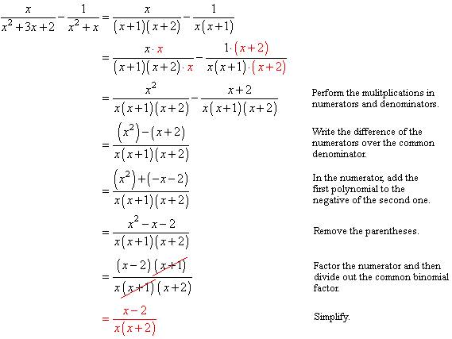

Additional Example 5:
Perform the following operations. Give all results in simplified form.
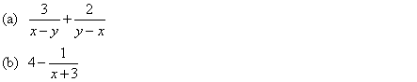
Solution:
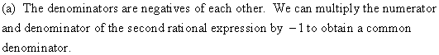

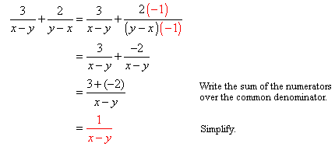

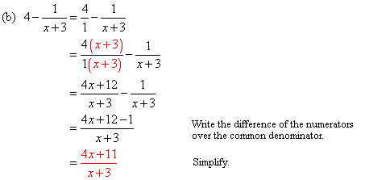

Perform the indicated operations and simplify. (Whenever possible, write both the numerator and denominator of the answer in factored form.)

Section 5.4: Complex Fractions

- Simplifying Complex Fractions

Simplifying Complex Fractions

Definition:
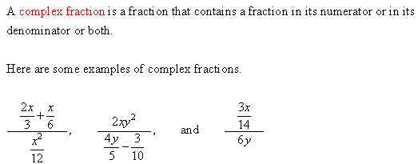

Simplifying:
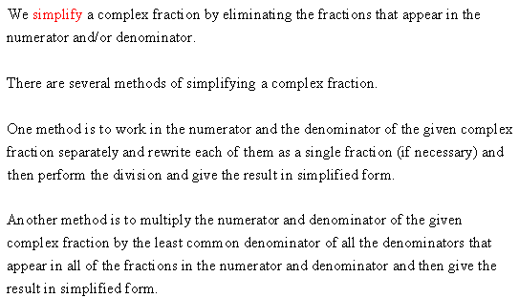

Example:
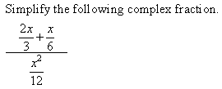

Solution:
Method 1:
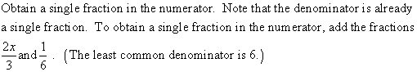

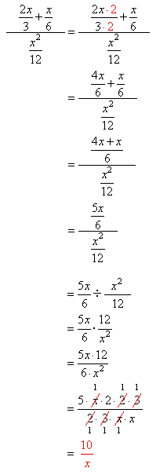

Method 2:
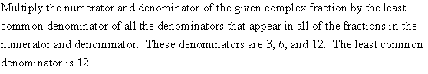

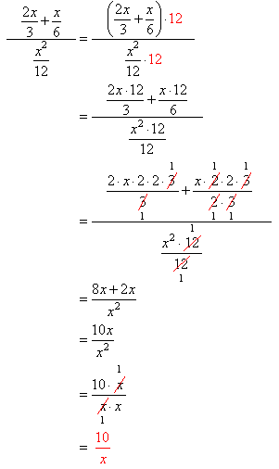

Additional Example 1:
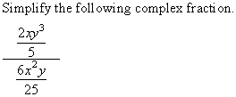

Solution:
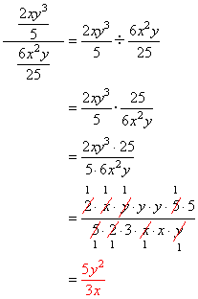

Additional Example 2:
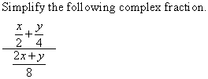

Solution:
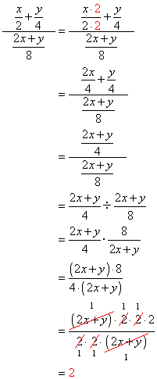

Additional Example 3:
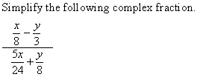

Solution:
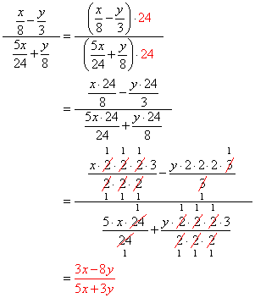
Additional Example 4:
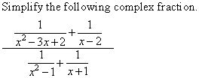

Solution:
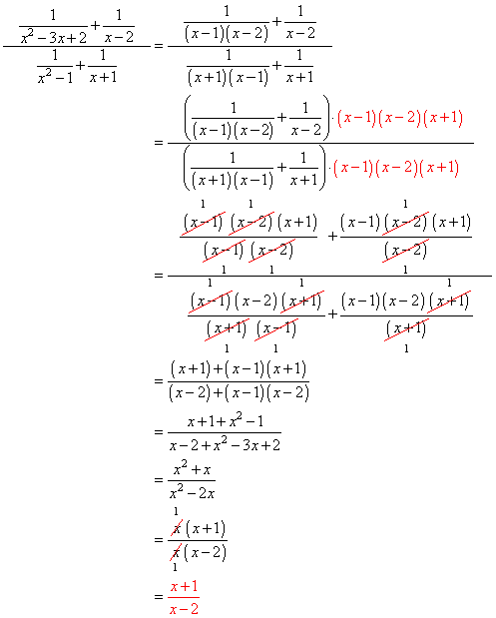

Additional Example 5:
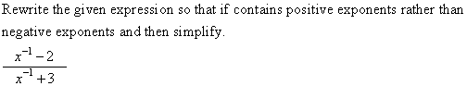

Solution:
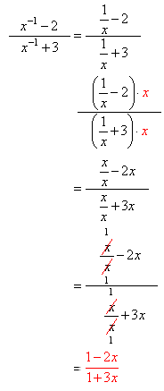

Simplify the following. No answers should contain negative exponents.

For each of the following expressions,
(a) Rewrite the expression so that it contains positive exponents rather than negative exponents.
(b) Simplify the expression.

Section 5.5: Solving Rational Equations

- Rational Equations

Rational Equations

Definition of a Rational Equation:
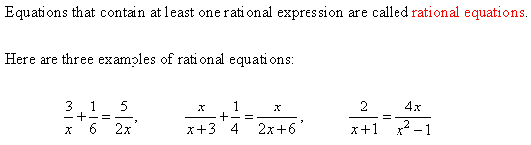

Solving a Rational Equation:
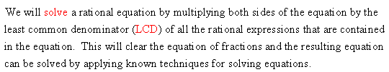

Example:
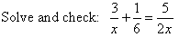

Solution:
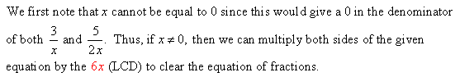

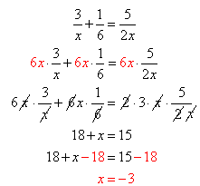

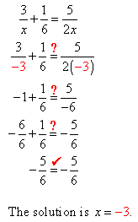

Example:
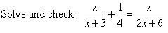

Solution:
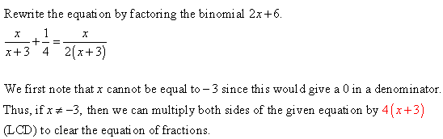

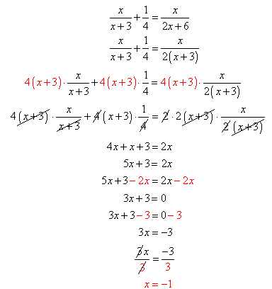

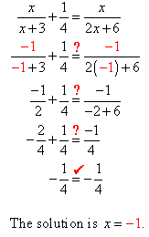

Extraneous Solutions:
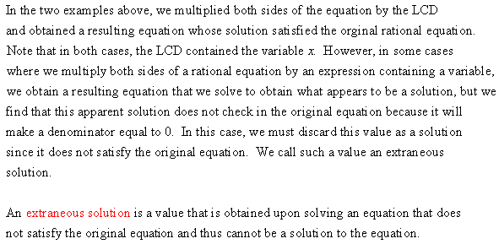

Example:
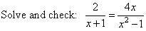

Solution:
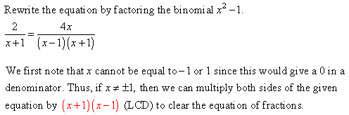

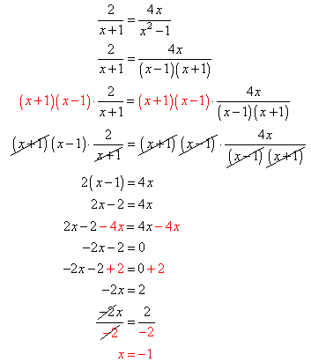

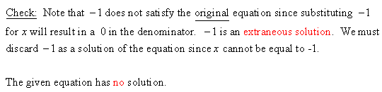

Additional Example 1:
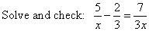

Solution:
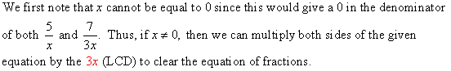

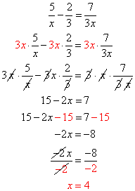
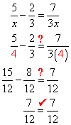

Additional Example 2:
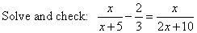

Solution:
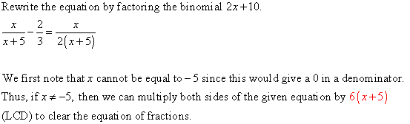

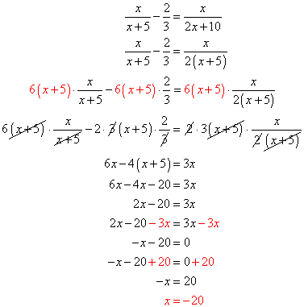

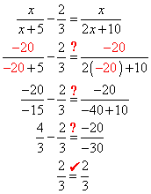

Additional Example 3:
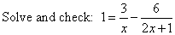

Solution:
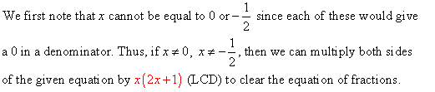
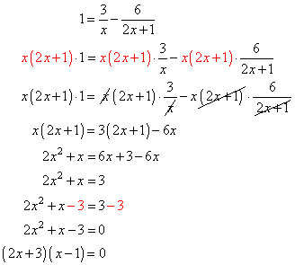

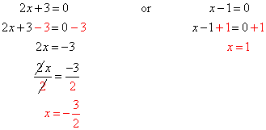

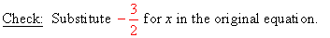
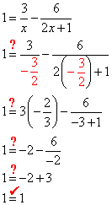

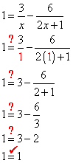
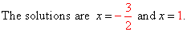
Additional Example 4:
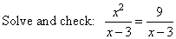

Solution:
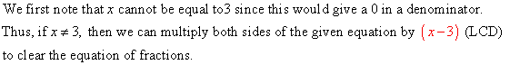
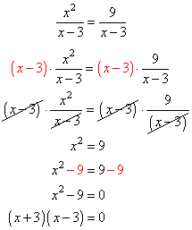

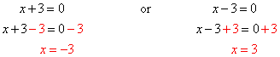

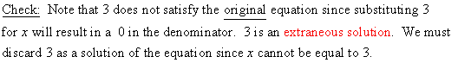

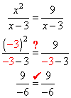

Solve the following. Remember to identify any extraneous solutions.

- $$\frac{2}{5x}+\frac{7}{4x}=−3$$
- $$−\frac{7}{6x}+\frac{5}{4x}=2$$
- $$\frac{4}{x−5}−\frac{1}{3}=\frac{−8}{3x−\text{15}}$$
- $$\frac{7}{x+2}+\frac{4}{3x+6}=−\frac{5}{3}$$

Section 5.6: Rational Functions

- Working with Rational Functions

Working with Rational Functions

Definition of a Rational Function:
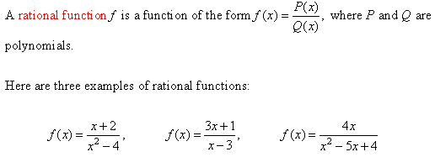

Domain of a Rational Function:
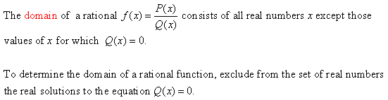

Example:
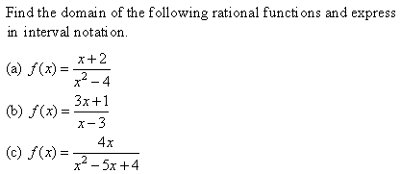
Solution:
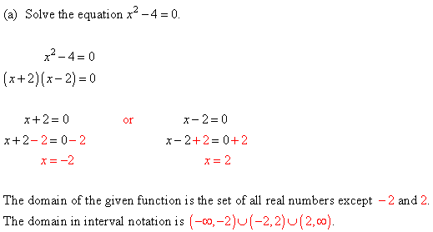

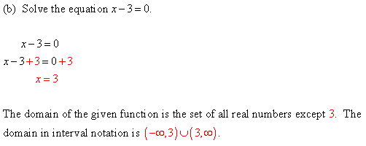

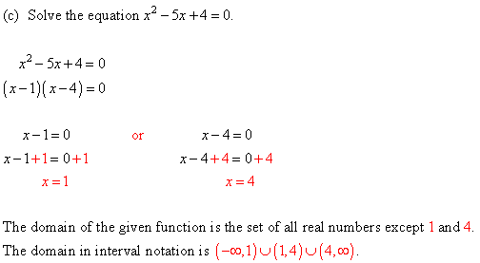

Graph of a Rational Function:
Example:
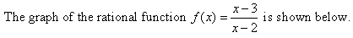
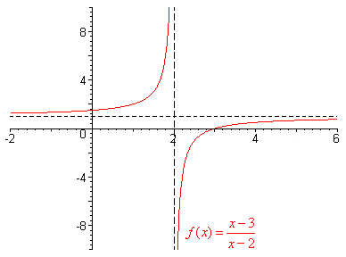

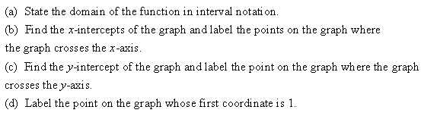

Solution:
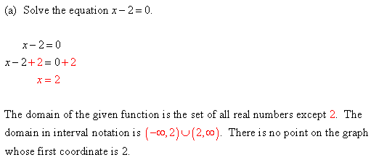

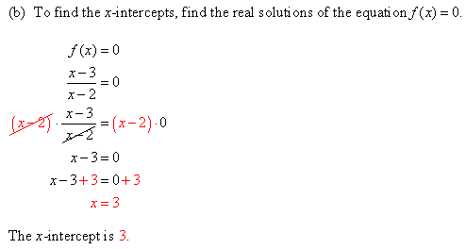

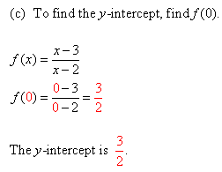

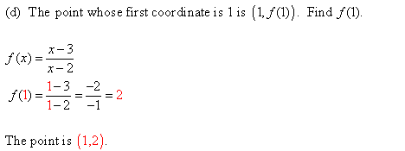

The graph of the function is shown below, labeled with the information from parts (b)-(d).
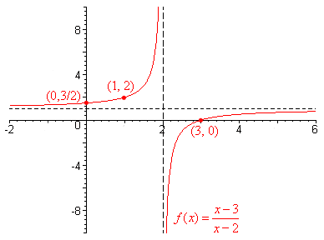

Vertical Asymptotes:
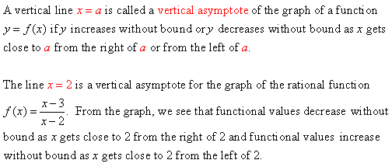

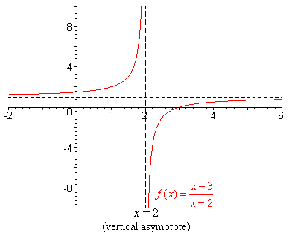
Finding Vertical Asymptotes
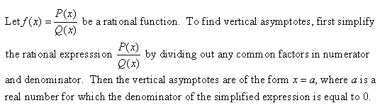

Example:
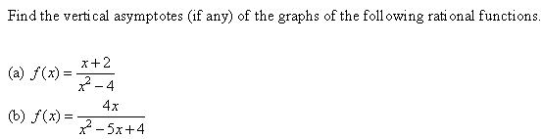

Solution:
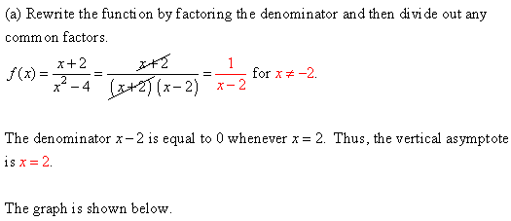

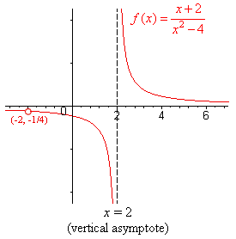
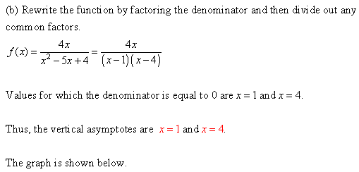

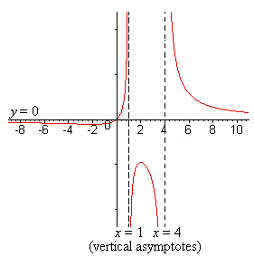

Horizontal Asymptotes:
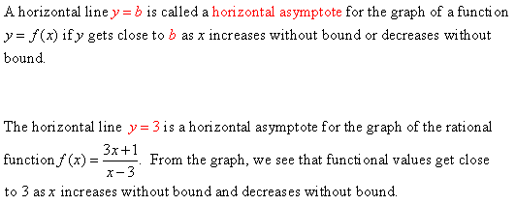

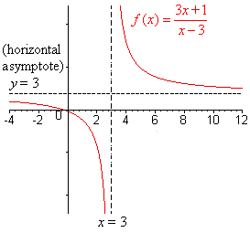

Additional Example 1:
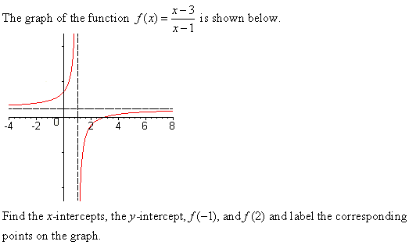

Solution:

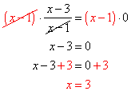

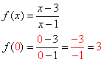

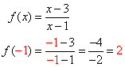

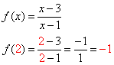
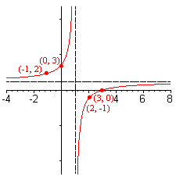
Additional Example 2:
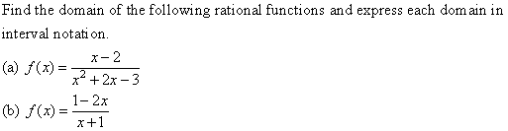

Solution:
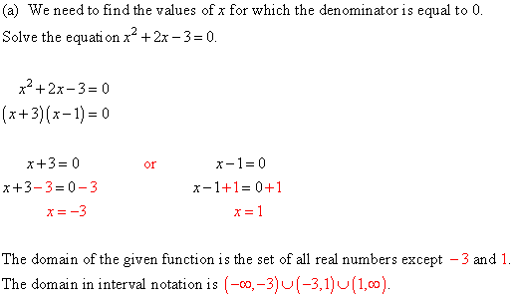

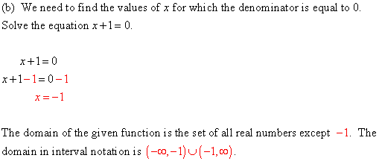

Additional Example 3:
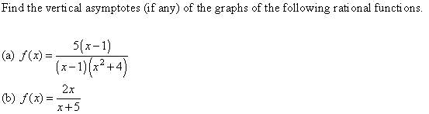
Solution:
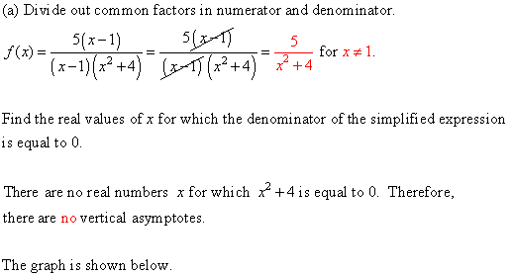

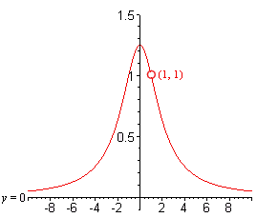

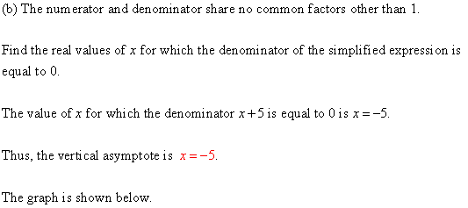

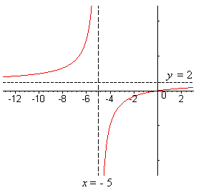

Find the indicated function values. If undefined, state “Undefined.”

- If , find
(a) (b) (c)

- If , find
(a) (b) (c)

- If , find
(a) (b) (c)

- If , find
(a) (b) (c)

- If , find
(a) (b) (c)

- If , find
(a) (b) (c)

- If , find
(a) (b) (c)

- If , find
(a) (b) (c)

- If , find
(a) (b) (c)

- If , find
(a) (b) (c)

The graph of each of the following functions has a horizontal asymptote at . (You will learn how to find horizontal asymptotes in a later mathematics course.) For each function,
(a) Find the domain of the function and express it as an inequality.
(b) Write the equation of the vertical asymptote(s) of the function.
(c) Find the x- and y-intercept(s) of the function, if they exist. If an intercept does not exist, state “None.”
(d) Find and .
(e) Based on the features from (a)-(d), match the function with its corresponding graph, using the choices (Graphs I-IV) below.

Graph IV:
Graph I:
Graph II:
Graph III:

The graph of each of the following functions has a horizontal asymptote at . (You will learn how to find horizontal asymptotes in a later mathematics course.) For each function,
(a) Find the domain of the function and express it as an inequality.
(b) Write the equation of the vertical asymptote(s) of the function.
(c) Find the x- and y-intercept(s) of the function, if they exist. If an intercept does not exist, state “None.”
(d) Find and .
(e) Based on the features from (a)-(d), match the function with its corresponding graph, using the choices (Graphs I-IV) below.

Graph IV:
Graph I:
Graph II:
Graph III:

For each of the following functions,
(a) Find the domain of the function and express it as an inequality. Then write the domain of the function in interval notation.
(b) Write the equation of the vertical asymptote(s) of the function.
(c) Find the x- and y- intercept(s) of the function. If an intercept does not exist, state “None."

- If

